Main article findings
El Nino categorisation (Toniazzo and Scaife (2006))
- Area average Niño3 (5°N-5°S, 150W-90°W) SST anomalies
- Strong: events Niño3>1.5°C
- Moderate: 0.83<Niño3≤1.5°C
- 23/24: 1.7C
NAO index: difference in sea level pressure (PMSL)
- 2 boxes located around Iceland (25°–16°W, 63°–70°N) and the Azores (28°–20°W, 36°–40°N)
- +NAO: Stronger-than-usual pressure gradient mild, wet, and stormy Atlantic weather systems across northern Europe and the UK
- - NAO: Weaker pressure gradient (or blocking high pressure) reduces the westerly winds and increases the likelihood of colder, more settled winter conditions in northwest Europe.
- Forecast vs. Observations in Winter 2023/24: Late winter El Niño events typically favour a negative NAO phase. However, during the 2023/24 winter, the observed NAO remained near-neutral (mean anomaly of -1.0 hPa), while the Met Office GloSea6 model predicted a weakly positive NAO (+2.4 hPa), resembling patterns seen during exceptionally strong El Niño years.
Anomalies for ERA5 and the model forecast: calculated with respect to the model hindcast period, 1993–2016, the climatological period used for HadUK is 1991–2020.
GS6: Met office forecast model
Had: Observations
Observations:
- Oct-Jan: 9 names storms (Table 1)
- Feb: cyclonic area extended further south than suggested by the ensemble mean forecast (Figure 1c) very mild and very wet weather, especially for southern regions of England, with more depressions tracking in from the southwest. Warmest February on record for England and Wales, and southern England had the wettest February on record.
Remote Influences – Figure 2 gives forecast and outcome nicely
- 2023 el nino event peaked in winter 23/24, well forecasted by GS6
- El nino predicted early by met office
- Historically, Europe El Niño winters contrasting conditions intraseasonal NAO shift
- However, strongest El Niño events (Niño3>1.5°C) different late winter response over the Atlantic with positive pressure anomalies over the East Atlantic extending to the UK and southwestern Europe, with low pressure anomalies to the north-east and south-west Rossby wave train emanating from the tropical Atlantic
- ensemble mean forecast agreed with observations figure 3 gives past SST anomalies, will be good for comparisons with 2026 magnitudes
- Other factors: Rossby wave, NOA, SSW, SPV (describe them in optional dropdown on website)
- Key driver of European climate anomalies in winter 2023/24:
  - Well forecast, strong El Niño event, with the forecast ensemble mean teleconnection patterns largely resembling the patterns from past strong events
  - However, differences in detail in the response complexity of driver combinations/role of unpredictable variability.
  - Generally, large-scale observed pattern correlation inc w/ the observed ENSO events strength.
    - Winter 2023/24 strong event adding to evidence of a non-linear response to El Niño over the European/Atlantic sector
Conclusions:
- Met office gave good guidance winter storminess, mild and wet, intraseasonal NOA shift
- Ensemble mean missed details feb 2024 more cyclonic than expected
- 9 named storms 2nd only to 11 in 15/16 (another strong el nino year get SST anomaly for comparison)
- Flooding, transport disruption, power outages (Kew et al 2024), agriculture
- NAO near neutral 23/24 pressure patterns only weakly affected NAO
- Other factors (SPV) badly forecasted

To do
Text – Lede (expand – template: https://www.bbc.co.uk/weather/articles/cmlye0d7q7zno), explanation, past el ninos obs vs predications, what to expect, action
Add explanation links (pressure, SST, NAO index, rossby waves, other stages)
Maybe NOAA charts to show cycle
NOAA links:
https://psl.noaa.gov/enso/dashboard.html
https://www.cpc.ncep.noaa.gov/products/CDB/Forecast/figf4.shtml
Figure links
Find out lag between peak nino3 and uk weather effects
Gov uk – warming stats: https://www.gov.uk/government/publications/impacts-of-el-nino-on-the-uk/impacts-of-el-nino-on-the-uk
What to do (accompanying document too): https://www.redcross.org.uk/stories/disasters-and-emergencies/uk/el-nino-and-the-uk
BBC news (accompanying document and title image) https://www.bbc.co.uk/news/uk-england-cumbria-36420312

Plan

Title & Lede Paragraph
(BBC News, 2016)
2026 Super El Niño: What to expect in the UK this Winter.
A Super El Niño is set to bring heavy rain and storms to the UK this December, with the potential to continue into late winter.
The latest NOAA update says the monthly average sea-surface temperatures in the central Pacific have reached their highest level on record and are forecast to continue to rise until December.
In the past, strong El Niño events have brought deaths, flooding, transport disruptions and power outages to the UK (Kew et al., 2024).

What actually is an “El Nino”?
El Niño is the warm phase of a naturally occurring climate cycle known as the El Niño-Southern Oscillation (ENSO). Caused by ongoing oceanic and atmospheric processes, the cycle usually lasts between three to seven years, involving three stages: El Niño, La Niña and ENSO-neutral. [Other stages link – check thresholds nino3 vs ONI]
Different regions across the globe respond uniquely to each stage. Generally, a northern European El Niño winter brings mild, wet and stormy conditions during the early winter (November-December), before shifting to colder, more settled weather later in the season. However, the very strongest El Niño events have been known to avoid this intraseasonal shift by triggering different atmospheric wave patterns, maintaining stormy weather and preventing the usual late-winter Arctic freeze in the UK.
[Actual html file – link to a sub page explaining NAO, pressure, SSW, rossby waves in more detail, polar vortex]

Why does El Niño happen, and what makes this one “super”?
The ENSO cycle depends on wind patterns and sea surface temperatures (SSTs) across the tropical Pacific Ocean. Under normal conditions, trade winds blow from east to west, pushing warm surface water towards Australia and Indonesia. During an El Niño event, atmospheric pressure shifts cause these winds to weaken or even reverse direction and blow from the west, allowing warm water to build up along the coast of South America instead. This change ocean surface heat alters atmospheric convection, leading to changes in global weather patterns, as shown in Figure 2. [actual html – link to sub page describing other stages of the cycle]
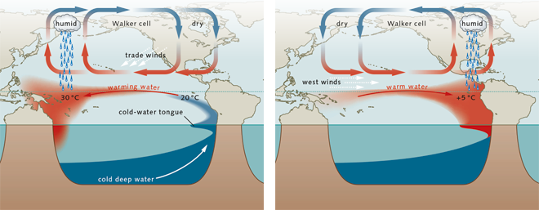
Figure 2: Trade wind reversal during El Niño. Have a look at how the hot water moving to South America causes clouds to form in that region. This is the beginning of the changes in global climate during El Niño (How El Niño forms, 2017).
To monitor the ENSO cycle, scientists measure SSTs across a region of the Pacific known as Niño3, shown in Figure 3. Temperature differences compared to long-term averages are called “anomalies”. The size of this anomaly indicates how severe global weather disruptions are likely to be, summarised in Table 1.
Table 1: Niño3 SST anomalies* and their corresponding El Niño intensities
Intensity | Niño 3 SST anomaly (°C)
Weak | < 0.83
Moderate | 0.83< Niño3 < 1.5
Strong | > 1.5
*Anomaly threshold for the other stages of the ENSO cycle can be found at
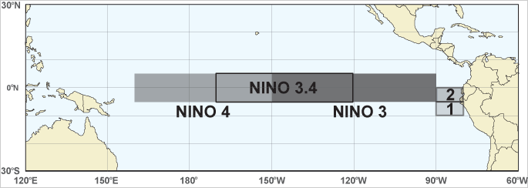
Figure 3: The different regions of the Pacific where SSTs are measured by the National Oceanic and Atmospheric Administration (NOAA) to monitor the ENSO cycle. Modern calculations tend to use the Niño3.4 region, to define official ENSO events, however Niño3 is most relevant in this case to allow historical comparison (NOAA, 2026b).
As of October 2026, the Niño3 region recorded a monthly average anomaly of +3.25°C, making it the highest recorded warming value for any El Niño season. NOAA forecasts this ocean warming to peak in December, as shown in Figure 4, suggesting the most active UK storm period will occur during early winter.
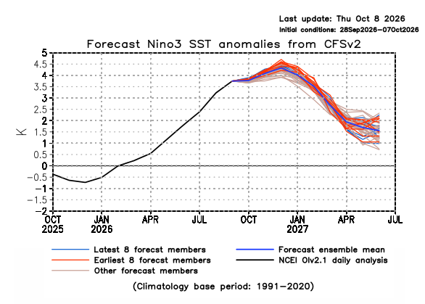
Figure 4: Predicted Niño3 anomalies for winter 2026. The black line shows observed values, currently approaching a 4 °C anomaly (plotted as +4K on NOAA charts). Follow the dark blue line to see the average prediction from NOAAs models, peaking in December as expected (NOAA, 2026a).

What happened during historical strong El Niño events, and how good were our predictions?
The UK has experienced several strong El Niño events in living memory. Going back to Table 1, a strong El Niño has an SST anomaly in Niño3 of at least 1.5°C. Notable El Niño events include 2023/24 and 2015/16.
So how do scientists predict El Niño events? To make an accurate weather forecast, two things need to be known (Bjerknes, 1904):
- The precise initial state of the atmosphere
- The physical laws controlling how the atmosphere behaves.
Making the forecast therefore begins with the Niño3 temperature measurements, alongside a large volume of weather data collected with various instruments around the globe [Maybe radiosonde/aircraft link – David schultz]. This information is then given to a computer model, which runs the physics calculations to try and make predictions. An important point about the reliability of this process is high resolution (zoomed-in) predictions further into the future areas quickly become inaccurate. The most reliable forecasts are low resolution (zoomed out), short-term estimates. This make exactly predicting the UK weather multiple weeks to months at a time difficult, as the UK is not a large area on a global scale.
The Met Office uses a seasonal forecast system called GloSea6 (GS6). Other institutions use their own versions. The details of the models are not important, but if you see “ensemble mean” anywhere in a figure or text, it just means the result is the combination of lots of models run on the same information to try and improve accuracy.
Models are tested using a technique called hindcasting, where they are run backwards in time to see how close they get to values we already know. Their future predictions are also compared to real world observations once they occur, using large datasets called HadUK, HadISST and ERA5. Once again, the details of the datasets are inconsequential, as long as it’s understood that forecasts are tested against real data once we know it.
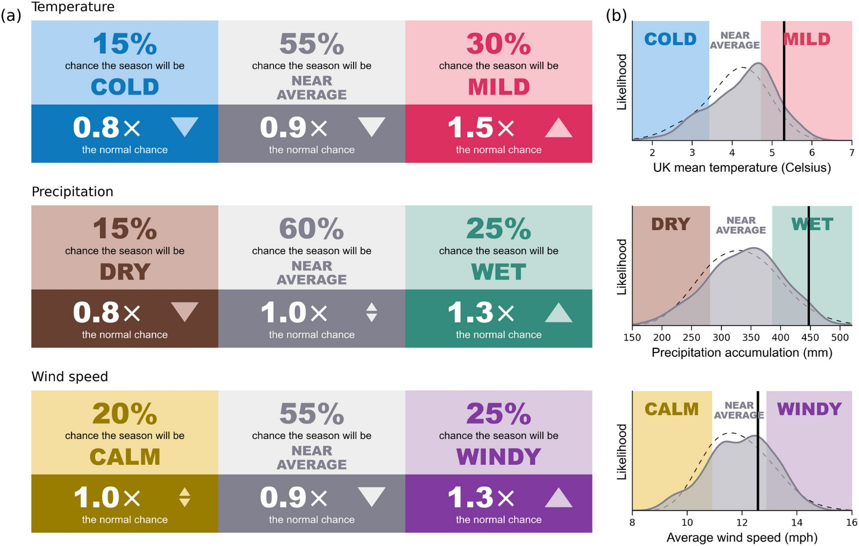
Figure 5: The Met Office forecast for December – January – February (DJF) 2023/24
(a) Shows an increased likelihood of mild (1.5× normal chance), wet (1.3×), and windy (1.3×) weather. This aligns with the strong El Niño pattern outlined earlier, where storminess dominates throughout the season instead of shifting to cold, clear weather.
(b) Compares the forecast likeliness (solid curve with grey shading) against historical averages (dashed grey curve). The solid black vertical line marks the actual recorded outcome, demonstrating how closely the model anticipated the mild, wet, and windy conditions.
The 2023/24 event is an excellent case study for evaluating how well modern technology predicts El Niño impacts. Niño3 warming of 1.7°C over the DJF period defined it as a strong El Niño. As Figure 5 shows, the Met Office’s predictions were close to what actually happened, forecasting a milder, wetter winter, despite slightly overpredicting the chance of calm winds.
Although the models successfully estimated the general impacts, some key details were missed. The weather patterns bringing mild, wet, and stormy conditions travelled further south than the ensemble mean forecast suggested, contributing to the warmest February on record for England and Wales, and the wettest for southern England. These differences mainly amount to the fact that the atmosphere is an incredibly complex system, influenced by many combinations of factors alongside El Niño. [NOA/cyclone/anticyclones/pressure – figure 1 in article]
The impacts of the 2023/24 event were widespread across the UK. Flooding, transport disruption, power outages, and agricultural damage affected the nation. Over the extended winter season (October to March) there were 9 named storms, as shown in Table 2, which was second only to the 11 named storms in 2015/16 (Kew et al., 2024).
Table 2: Named Storms from Oct-Mar 2023/24
Name | Date of UK/Ireland/Netherlands Impact
Babet | 18-21 October 2023
Ciarán | 1-2 November 2023
Debi | 13 November 2023
Elin | 9 December 2023
Fergus | 10 December 2023
Gerrit | 27-28 December 2023
Henk | 2 January 2024
Isha | 21-22 January 2024
Jocelyn | 23-24 January 2024
Although 2023/24 is the most recent strong El Niño, the Niño3 region warmed by “only” 1.7 °C during DJF. Whilst this still classifies it as a strong event, 2026 is already at a record-breaking 3.25°C and is expected to continue rising until it peaks in December [fig4 link]. Because of this extreme warming, 2015/16 may be more comparable to what we might see this winter, still being a relatively recent occurrence whilst having a with higher peak Niño3 warming of around 2.5°C, shown in Figure 6 [link].
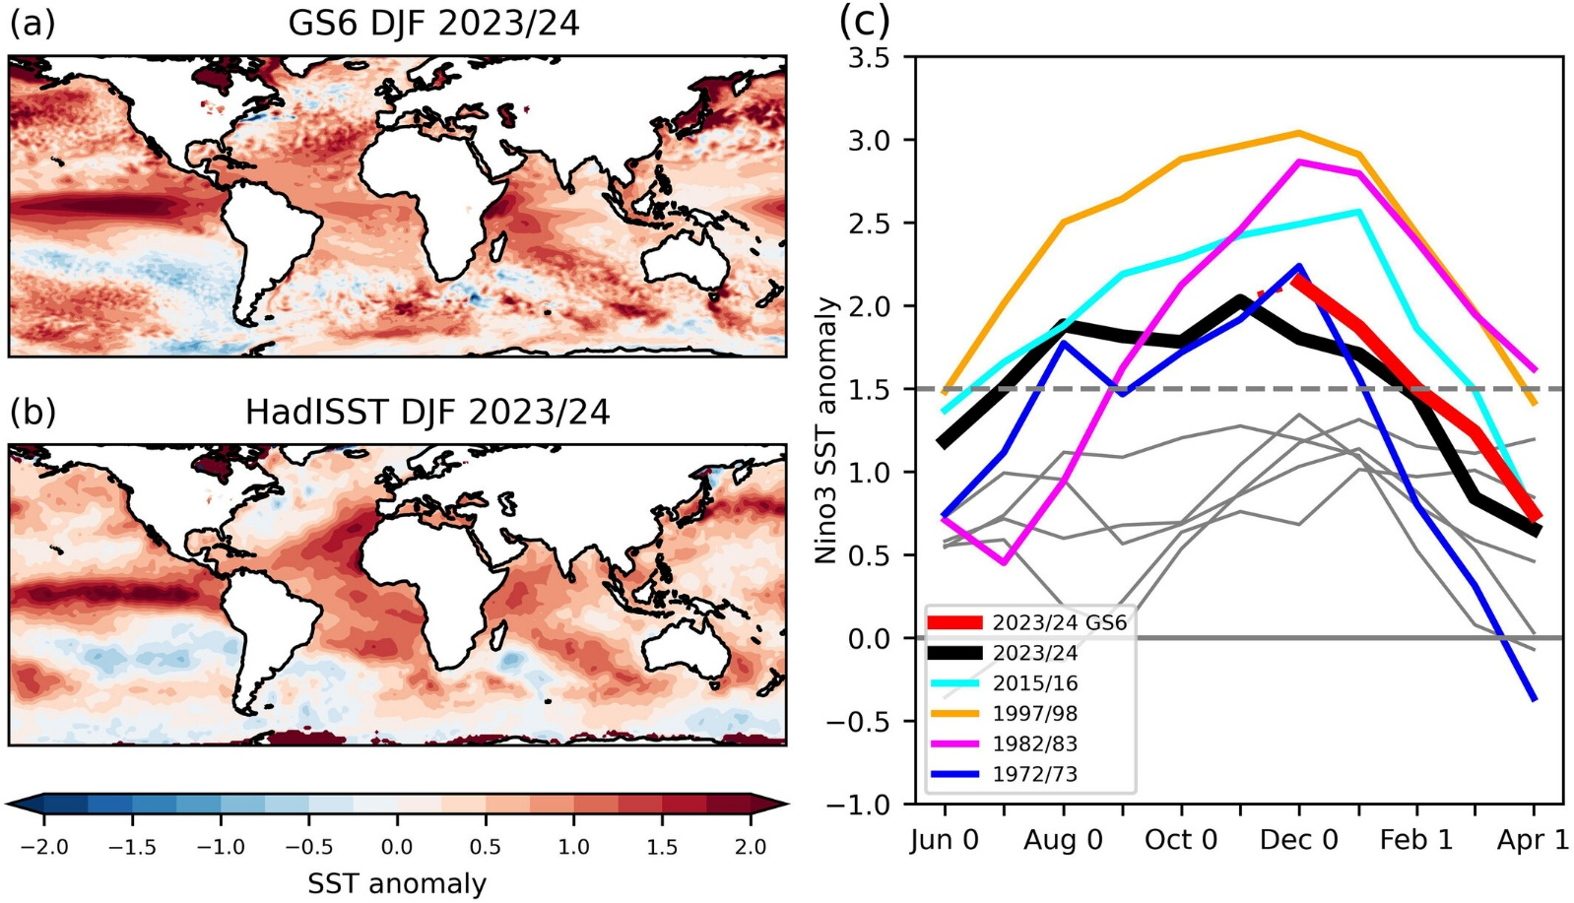
Figure 6: 2023/24 winter sea surface temperature patterns and Niño3 anomalies across different years
(a) The Met Office’s ensemble mean forecast
(b) Actual recorded observations
(c) SST anomalies from June to April for strong (colours) and moderate (grey) El Niño events since 1950. Observations for 2023/24 are shown in black, while the ensemble mean forecast (initialised in November) is shown in red. The dashed grey line at 1.5°C marks the boundary between ‘moderate’ and ‘strong’ El Niño.
The 2015/16 El Niño caused an exceptional winter across the UK and Ireland, breaking numerous climate records and bringing high-impact weather events that caused considerable disruption from flooding and high winds. A succession of winter storms tracked across the region, bringing persistent rainfall including the highest 24-hour and 48-hour rainfall accumulations on record during storm Desmond from 4 to 6 December. Temperatures were also exceptionally mild through much of December and in late January, consistent with the theme of especially strong El Niños avoiding the intraseasonal shift to colder, clearer weather. Figure 7 shows the precipitation and temperature anomalies across the UK and Ireland from December to February.
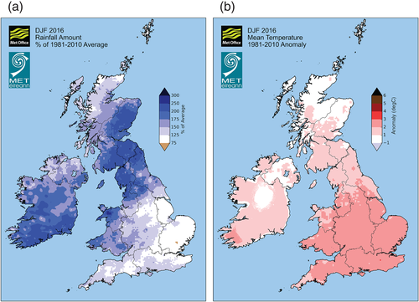
Figure 7: (a) Precipitation and (b) temperature anomalies across the UK and Ireland.
The unusually wet and mild conditions are clearly visible. The north-west of the UK was severely affected by excess rainfall, whereas the south of England saw the greatest temperature increases above average. Broken down by month, both anomalies were strongest in December, coinciding with the peak Niño3 warming (McCarthy et al., 2016).
One of the worst affected areas during the 2015/16 winter was Cockermouth, Cumbria. On the 5th of December 2015, 36 hours of intense rainfall led to nearly five metres of flooding after local defences failed, damaging nearly 500 properties and causing at least one loss of life. The excess rainfall is visible in Figure 7, where north-west England experienced over 200% of the average rainfall usually seen between December and February (BBC News, 2016).
One of the worst-affected areas during the 2015/16 winter was Cockermouth, Cumbria. On 5 December 2015, 36 hours of intense rainfall led to nearly five metres of flooding after local defences failed, damaging almost 500 properties and causing at least one loss of life. This extreme excess rainfall is clearly visible in Figure 7, which shows that north-west England experienced over 200% of the average precipitation typically seen between December and February (BBC News, 2016).

Section 4: The Science Behind the Shifts: Atmospheric Waves and the Polar Vortex Paradox (~250 words)
[Actual html file – link to a sub page explaining NAO, pressure, SSW, rossby waves in more detail, polar vortex]
- Goal: Explain the core physical mechanisms without confusing technical jargon.
- Drafting Blueprint:
  - Non-Linear Threshold: Explain that moderate El Niño events often cause cold, dry conditions in late winter, but strong El Niño events trigger a completely different atmospheric chain reaction.
  - Atmospheric Waves: Introduce Rossby waves as massive energy ripples in the atmosphere triggered by tropical ocean heat that travel across the Atlantic Ocean.
  - The Sudden Stratospheric Warming (SSW) Paradox: Explain the discovery from Ineson et al. (2026) regarding the mid-January 2024 Arctic wind collapse. Normally, an SSW unleashes severe Arctic freezes across the UK, but atmospheric waves from strong tropical warming overrode and masked the Arctic freeze, keeping UK temperatures surprisingly mild.
Section 5: What the UK Public Should Expect for Winter 2026 (~150 words)
- Goal: Apply the scientific principles from Ineson et al. (2026) to forecast expectations for the upcoming 2026 season.
- Drafting Blueprint:
  - Early Winter Outlook (December 2026): Prepare the public for a high probability of wet, windy Atlantic depressions arriving in rapid succession, driven by persistent low pressure to the north-west of the UK.
  - Late Winter Outlook (January–February 2027): Explain that while higher pressure may build near the UK to bring temporary settled breaks, southern storm tracks could still deliver localized heavy rainfall surges.
Section 6: Actionable Preparation and Community Resilience (~120 words)
- Goal: Offer concrete guidance for readers, councils, and emergency services.
- Drafting Blueprint:
  - Household Actions: Advise checking local flood risk maps, clearing private drainage gullies, and subscribing to Met Office impact-based warnings before early-winter storm cycles begin.
  - Civic Infrastructure: Conclude by highlighting how local authorities are expanding sustainable urban drainage systems, green roofs, and nature-based solutions to absorb intense rainfall from repeated storm cycles

Reference list
BBC News (2016) Storm Desmond 'overwhelmed Cockermouth flood defences'. Available at: https://www.bbc.co.uk/news/uk-england-cumbria-36420312 (Accessed: 01/11/2026).
Bjerknes, V. (1904). ‘Das Problem der Wettervorhersage, betrachtet vom Standpunkte der Mechanik und der Physik’ Meteorologische Zeitschrift, 18 (6), pp. 663-667 https://doi.org/10.1127/0941-2948/2009/416.
How El Niño forms (2017). World Ocean Review. Available at: https://worldoceanreview.com/en/wor-5/climate-change-threats-and-natural-hazards/coping-with-natural-hazards/how-el-nino-forms/ (Accessed: 20/11/2025).
Kew, S. F., et al. (2024). Autumn and Winter storms over UK and Ireland are becoming wetter due to climate change: Centre for Environmental Policy. https://doi.org/10.25561/111577.
McCarthy, M., et al. (2016). ‘The meteorology of the exceptional winter of 2015/2016 across the UK and Ireland’ Weather, 71 (12), pp. 305-313 https://doi.org/10.1002/wea.2823.
NOAA (2026a) El Niño Index Dashboard. Available at: https://psl.noaa.gov/enso/dashboard.html (Accessed: 31/10/2026).
NOAA (2026b). Map of ENSO regions.] Available at: https://psl.noaa.gov/enso/img/oceanic-indices-map.gif (Accessed: 31/10/26).

